MI 24 Hind Specs

|  |
| --- |
| Mi-24 Hind F fitted with twin 30mm cannons. |

The MI-24 Hind A Gunship came into service in the Soviet Military in 1976. It's introduction caused consternation amongst NATO forces as they had no comparable system in their arsenal. The AH-64A Apache gunship's development was a direct consequence of the Hind's appearance in the Soviet order of battle.

Bigger than most other gunships, the bulky Hind carries a large weapon layout of cannons, rockets and anti-tank missiles. The Hind is also able to carry up to 7 troops or 14 stretchers in the med-evac role.

The MI-24 Hind sacrifices maneuverability for speed and survivability. Whilst the Hind can take off and land vertically it is not able to hover and maneuver like other gunships and so is flown into combat more like a ground attack plane such as an A-10 Thunderbolt. The helicopter's large wings not only provide plenty of space for rockets and missiles but also provide some much needed lift for the heavy Hind. The Hind holds the world speed record for active military helicopters.

The initial 'A' model was quickly upgraded into the Hind-D. The Hind-D replaced the squared-off crew canopy with a distinctive 'bubble' design, improved armor, avionics and weapons systems. In later Hind-F models, the chin-mounted 12.7mm cannon pod was replaced with fuselage-mounted twin 30mm cannons - the result of lessons learned during the Afghanistan war where it was discovered that a larger caliber weapon than 12.7mm was required for air-to-ground attack missions.

The MI-24 Hind saw combat in Afghanistan where initial success was tempered by growing losses to man-portable anti-aircraft missiles such as US-supplied Stingers. The Hind-D was exported to several African nations where it has seen action in many a conflict there. Angolan Hind-D gunships fought against South African forces during the Angolan war of independence (1961-1989). They have also flown into combat in Sierra Leone during the civil war there. One MI-24 provided fire support to the British Special Forces mission, 'Operation Barras', in Sierra Leone, 2000 ([**see here for more details**](http://www.eliteukforces.info/special-air-service/sas-operations/operation-barras/)). Russian Hinds have also fought with distinction in the Chechnya conflict.

related info : [**MI-24 Super Hind**](http://www.guncopter.com/super-hind/)

related info : [**MI-24 Variants**](http://www.guncopter.com/mi-24-hind/mi-24-variants.php)

**MI-24 Hind D/F Specifications**

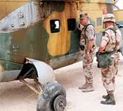

The Hind includes a cargo compartment for transporting troops / stores. Door guns can be mounted if required.

|  |  |
| --- | --- |
| Crew | 2 - With Pilot seated above and behind Gunner + 2 door gunners (optional) |
| Engines | Two Klimov 1500-hp TV3-117 turboshafts |
| Dimensions | L - 17.51m W (rotor diameter) - 17.30m  H - 3.97m |
| Weights | 8200 kg (empty) 26,455 kg (max loudout) |
| Max Speed | 180 kt (279 kph) |
| Range | 1000 km - with external fuel pods |
| Armament | One 12.7 mm four barrel YakB machine gun in rotating gun pod / twin 30 mm cannon on fuselage 4 x anti-tank missiles (at-2 / at-6) rocket pods door-mounted machine guns bomblets |

|  |  |  |
| --- | --- | --- |
| Typical loadouts include UV-32-57 rocket pods each containing 32 S-5 57mm rockets and AT-2 wire-guided Swatter or AT-6 laser-guided anti-tank missiles. | The MI-24D's cannon pod includes a JakB multi-barrel 12.7mm cannon, electro-optical sensors and a laser guidance pod. Later 'F' models favoured twin-barreled GSh-23 30mm cannons fixed to the fuselage. | **MI-24D HIND-D FEATURES**   * infra-red jammers * rotors designed to withstand heavy ground fire * engine exhaust suppressors reduce IR signature * flare launchers fiited to tail-boom * armoured cockpits and canopies fitted with bullet-proof glass. * troop/cargo/stretcher compartment |

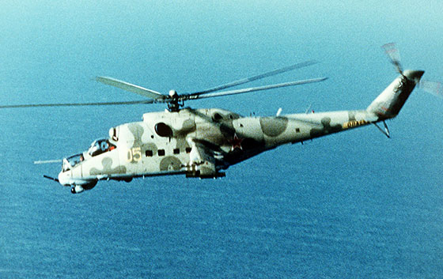

MI-24 Hind-D Gunship with distinctive bubble canopy and steerable 12.7mm cannon pod.

**MI-24 Hind resources :**

**MI-24 HIND PHOTOS :**  
  
(click thumbnails for fullsize images)  
[**photo gallery : MI-24 HIND**](http://www.guncopter.com/photos/mi-24-photos.php)   
  
**MI-24 VIDEO :**  
[**MI-24 showcase**](http://www.guncopter.com/video/mi-24-video-1.php)  
  
**MI-24 LINKS**  
[**Mil Helicopters - Official Manufacturer's Website**](http://www.mi-helicopter.ru/)

